Zonions App

* **Technology Used**
  + 1. React : Front End
    2. MongoDB : Database
    3. Express And Node : Backend
* **Backend API**

1. Admin Login – Method : POST

localhost:3000/login

1. For Creating Restaurant – Method : POST

localhost:3000/restaurants

1. For Updating Restaurant – Method : PUT

localhost:3000/restaurants:restId

1. For Deleting – Method : DELETE

localhost:3000/restaurants:restId

1. For View – Method : GET

**Single Record**

localhost:3000/ restaurants:restId : Get

**For all Record**

localhost:3000/restaurants : Get

* React Components
  + 1. User HomePage

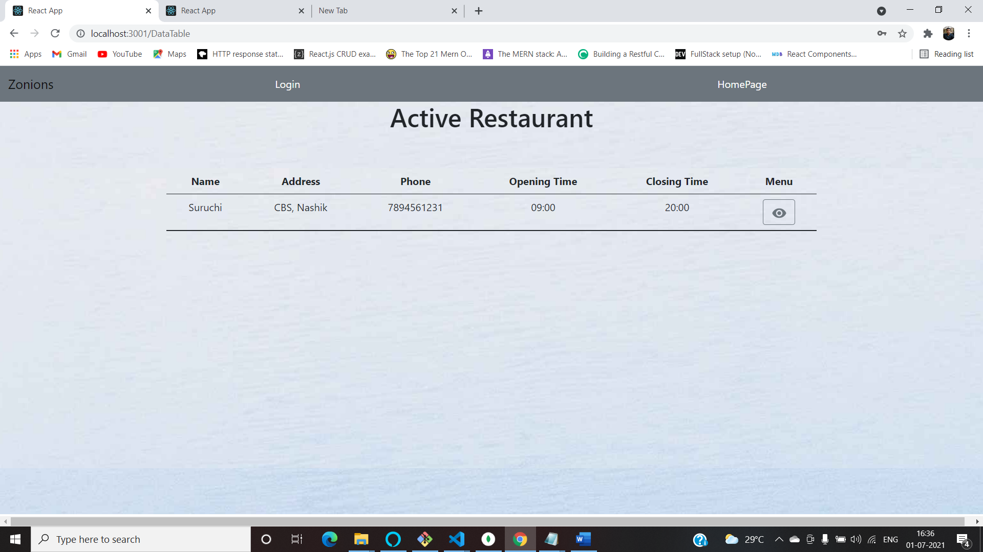

* + 1. Admin Login

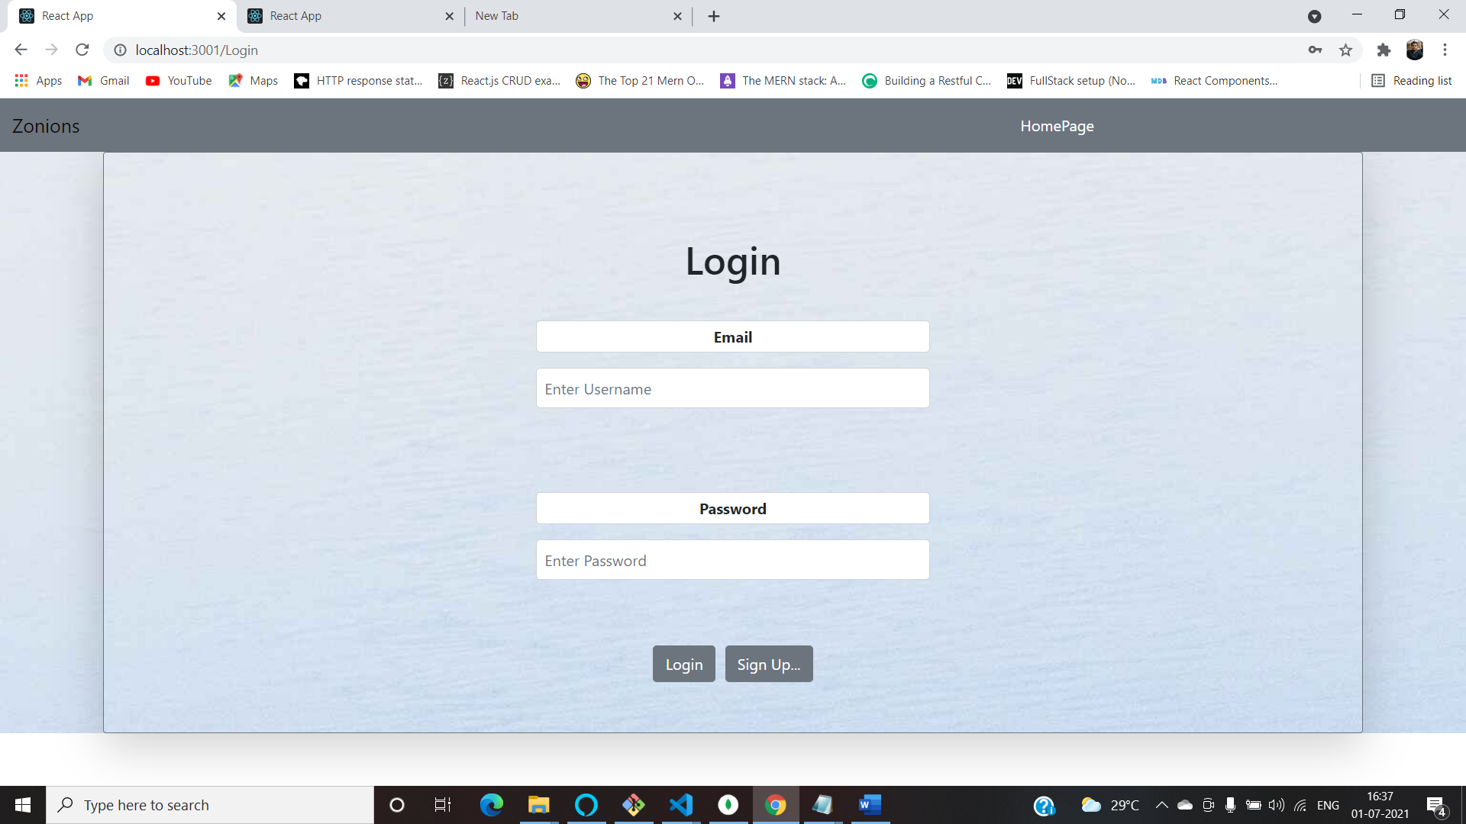

* + 1. Admin DashBoard/HomePage

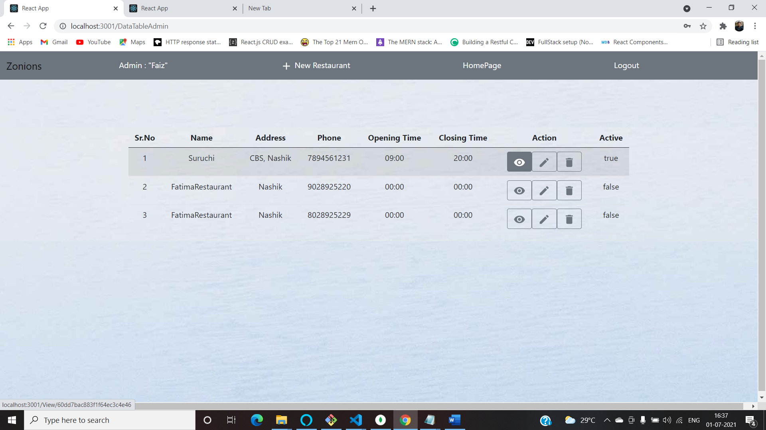

* + 1. Add Restaurant

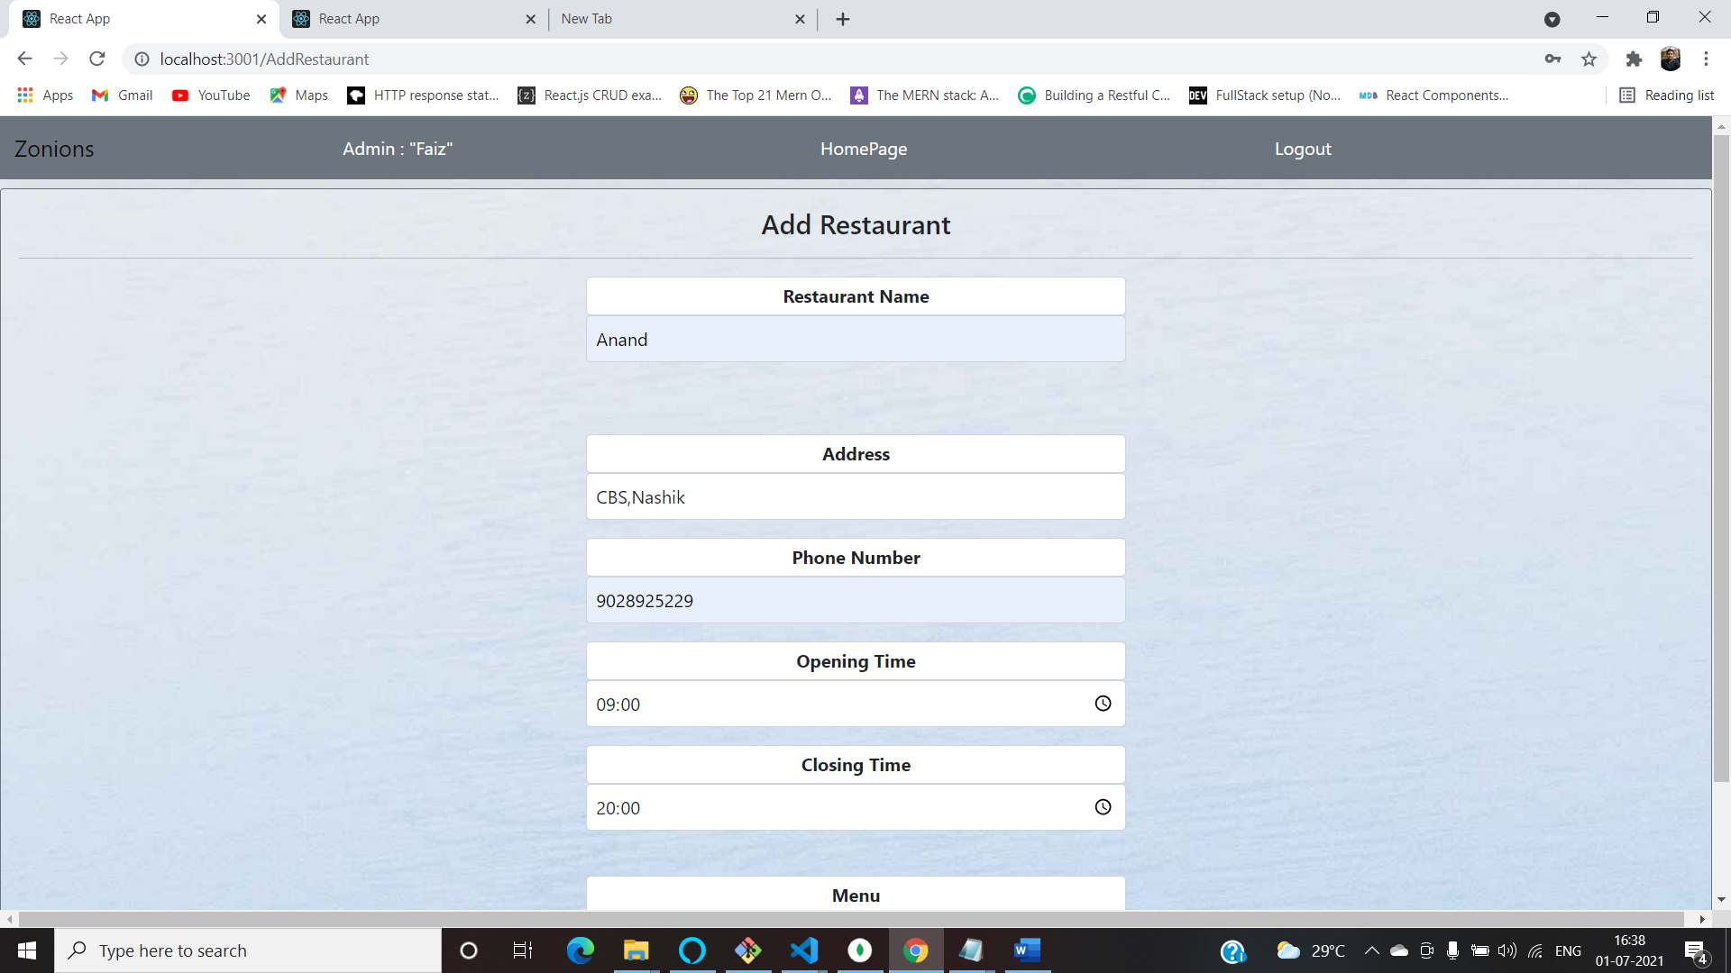

* + 1. Edit Restaurant

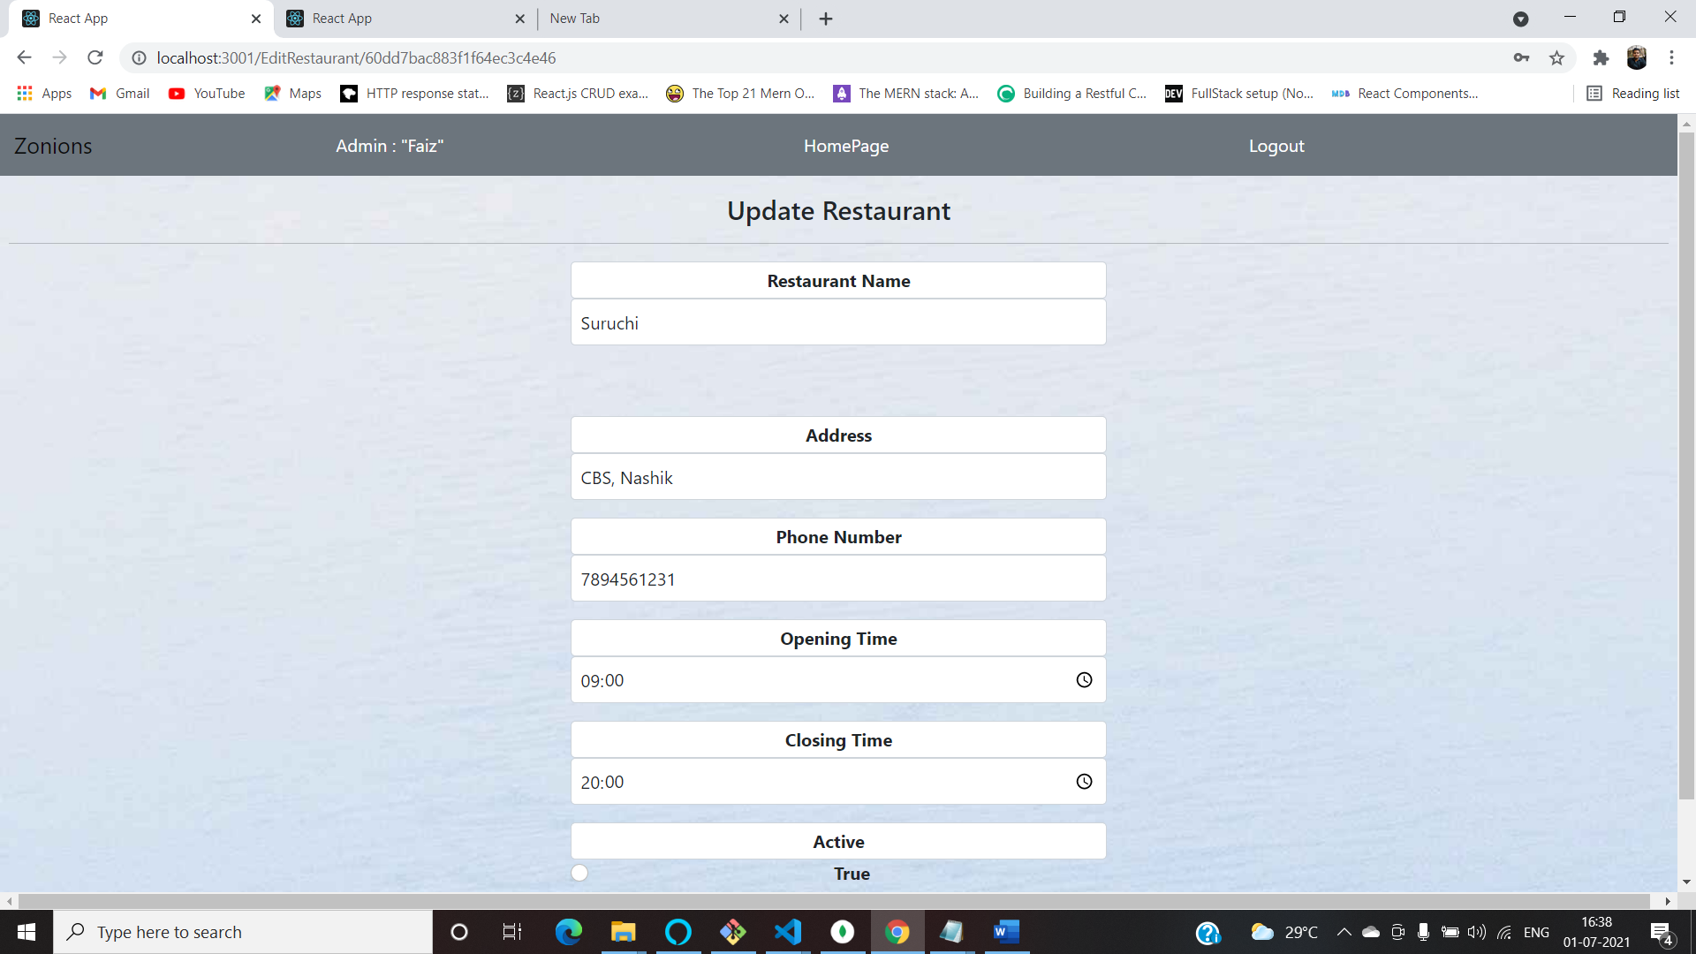

* + 1. View Restaurant

